CEO CONNECTION CALLS | 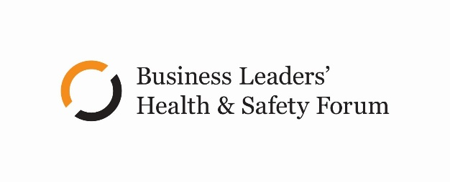
Living With COVID
Summary of discussions with 40+ CEOs
November-December 2021
From late November to early December 2021, we talked with more than 40 CEOs from across New Zealand, and many industries about the current leadership challenges CEOs and their businesses are confronting as we transition from eliminating COVID to living with COVID. This is a summary of the key themes, challenges, and approaches shared on those calls.
The mental wellbeing temperature is rising…and 'won't get cooler in 2022
People are struggling
An almost universal theme was a shared sense that more people (workers and leaders alike) were struggling than usual. There was a sense that a range of factors was driving that threat to worker wellbeing:
- Ongoing uncertainty of COVID
- Pressures with supply chain
- Vaccination division
- Increasing talent constraints and turnover
- Already depleted energy levels following on from 2020
Reframe the context
A number of CEOs talked about how 'they've sought to reframe the current and difficult realities:
- Providing a sense of confidence that ""COVID will pass"", but it will take time
- Acknowledging the uncertainty, but emphasising the factors people and the business can control (e.g., the fundamental purpose of the business, COVID tools such as vaccines, good plans, PPE etc)
- Ensuring that "green shoots" and positive signs of progress are called out and acknowledged
Building capacity for a marathon, not a sprint
Numerous CEOs referenced how COVID is a medium to long-term challenge that will continue to throw disruptive and unanticipated variables into the mix. It was in that context that a number of leaders talked about the importance of building and maintaining capacity in our people"" as we navigate the ongoing uncertainties.
Practical strategies that were shared for how CEOs are looking to build and retain that capacity across their teams included:
- Deliberately looking to manage down work demands on the organisation and teams
- Proactively engaging clients to moderate delivery timeframes in the short term to deliver over the long term
- Transparently and publicly giving frontline managers and workers more ""permission"" to self-determine"" work pace
- Stronger encouragement to utilise annual leave over summer – one CEO talked about requiring workers to use at least 7 days leave over the December-January months
""We 'can't win this race if we are running at 120% now – we need the capacity to negotiate the bumps. We need to be running at 95% so we have some energy in reserve"."

Vaccinations – critical control, but also cultural divider and workforce threat
Vaccination as the critical control
There was universal consensus on the primary importance of vaccinations as a COVID risk control. Equally, almost all participants reported a high (tracking towards or above) 90% vaccination rate across their teams. Less than a quarter of those on the calls had consulted on or instigated a vaccination mandate, although the majority worked on other people's sites or with clients that required vaccination certificates. However, it is noted that many organisations are now in consultation on mandating.
Social tensions are mounting
Most reported a sense of growing tensions surrounding government, client and company vaccinations requirements.
Several CEOs talked in different ways about how they have increasingly sought to frame the COVID risk as being more than simply about vaccination. This involved broadening the ""COVID-safe"" discussion beyond the vaccine and talking more fully about the integration of other risk controls – both to prevent and minimise the harm from infection. See Living with Covid Principles.
Workforce issues 'aren't getting any easier
Ongoing closed borders continuing to constrain migrant workers, coupled with vaccine-hesitant workers, led to most CEOs reporting sustained and significant threats to staff recruitment and retention.
The impact of this threat was seen as doubly impactful given the already stretched capacity of most teams (see earlier point about mental wellbeing).
Supply chain and PCBU (mis)alignment
There was a range of commentary about variations in risk tolerance across organisations whose people worked on other sites. In some cases, these differences were worked through reasonably, given the presence of a healthy relationship.
In other cases, there were examples of some members feeling like the risk and expectations of vaccinations and COVID controls had been ""thrown over the fence"" rather than actively engaged and finding agreement on.
""It was like when the HSW Act first came in and we were all getting our heads around overlapping PCBUs – risks were simply being pushed down with no care – I thought we were past that"."
Preparing for COVID incursion – when, not if
A strong and recurring theme was increased organisational preparedness and assurance for responding to the inevitability of a COVID infection in the business.
Incursion planning
This ""incursion response"" was largely framed in response to three drivers – protecting worker health, ensuring business continuity and maintaining business reputation. ee Living with Covid Principles.
The most common and key controls in this incursion response included:
- Enhanced and additional tracing – examples included Bluetooth tracking and extra onsite QR codes. This was largely informed by reports of increasingly slow response times from MoH tracing timeframes
- Reinstating shift separation and bubbles to reduce business interruption risks and limit infections
- Scheduling work teams to lower levels of public exposure leading up to big projects
- Ensuring vaccination was framed as a ""recovery control"" as well as a preventive control
- Starting to incorporate RAT testing to quickly identify any additional infections. See the Forum's insights from the RAT pilot
- Clear and available information about ventilation (e.g., filter information, airflow, maintenance etc)

